Software Updates Test Results

Perhaps you have two different types of end user machines. One type, the machines can be rebooted whenever software updates get applied according to the Change Schedule. The other type, the machines can NOT be rebooted. However, software updates still need to be installed on them and the business owner would be responsible for the reboot. The goal is to get the updates to install on both types of machines, but prevent a reboot for the business critical machines. Attached are screen shots and test results of the various methods used when configuring and installing software updates.

TEST 1
- Test automatic reboot push and manual reboot push with the following settings
  - Software Update Client Agent – Hide all deployments from end users
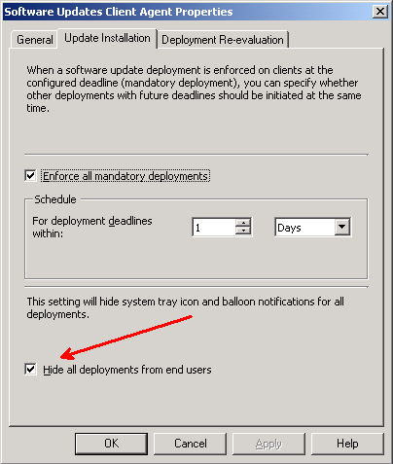

  - Two SCCM Collections have been set up
    - Workstations – Manual Reboot
      - XP-2
      - XP-3
        - NOTE: Both these machines will use the BDP on XP-3 as their content source
    - Workstations – Automatic Reboot
      - XP-1
  - Two SCCM Software Updates Deployment Management Packages
    - Workstations – 2010 Updates – Windows XP – Automatic Reboot
      - This will be targeted to the Workstations – Automatic Reboot collection
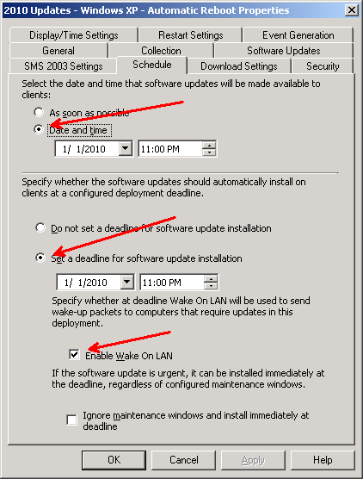
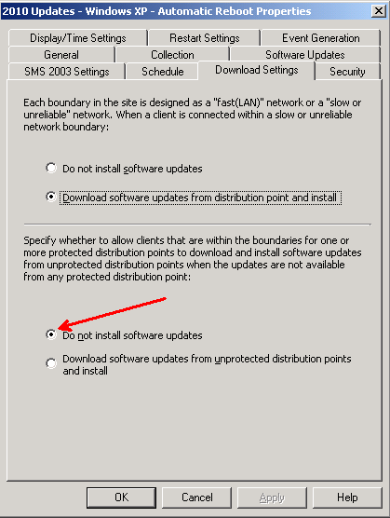

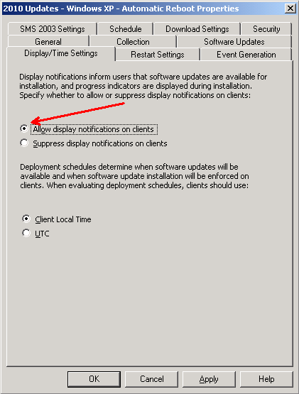

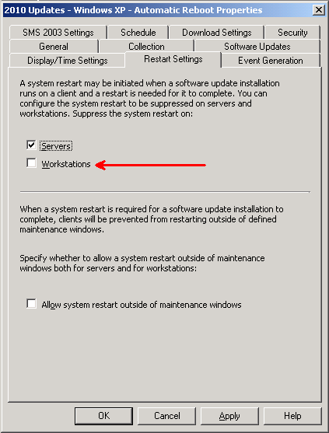

    - Workstation – 2010 Updates – Windows XP - Manual Reboot
      - This will be targeted to the Workstation – Manual Reboot collection
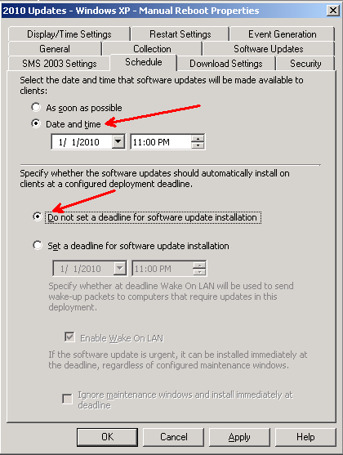

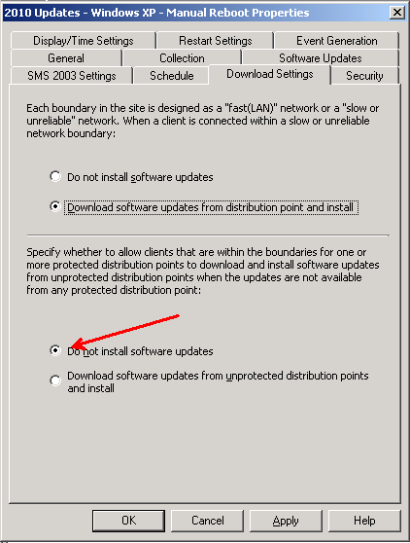
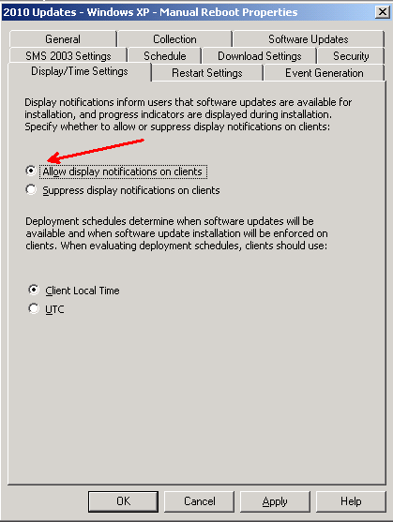
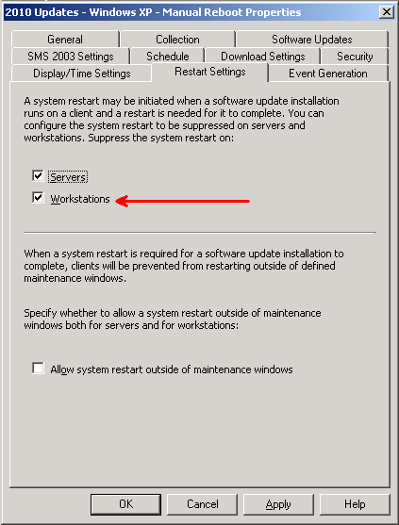

  - Results
    - XP-1 – Part of the Workstation Automatic Reboot collection
      - Looked at the ContentTransferManager.log to verify that the source files were being downloaded from the correct DP.
      - Successfully brought up the 90 minute reboot message
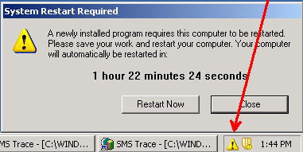

    - Carlson XP2 and Carlson XP3 – Part of the Workstation Manual Reboot collection
      - Looked at the ContentTransferManager.log to verify that the source files were being downloaded from the BDP.
      - No messages or pop-ups were seen.
  - This option does not meet the needs of displaying messages. The automatic updates worked great, but the manual one does not show any indication that a reboot is pending.

TEST 2
- Test automatic reboot push and manual reboot push with the following settings
  - Software Update Client Agent
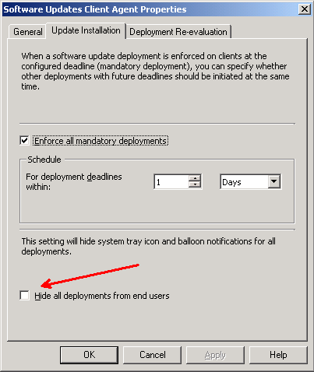

  - Two SCCM Collections have been set up
    - Workstations – Manual Reboot
      - XP-2
      - XP-3
        - NOTE: Both these machines will use the BDP on XP-3 as their content source
    - Workstations – Automatic Reboot
      - XP-1
  - Two SCCM Software Updates Deployment Management Packages
    - 2010 Updates – Windows XP – Automatic Reboot
    - This will be targeted to Workstations – Automatic Reboot collection

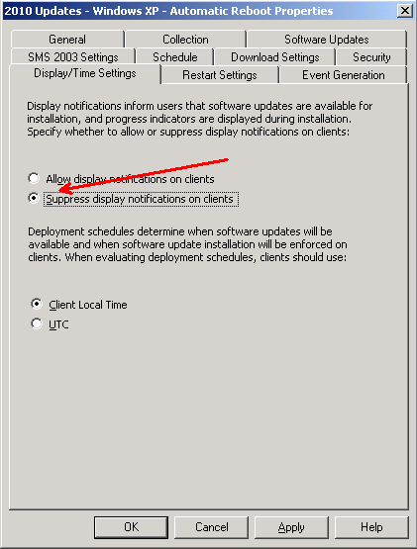

    - Workstations – 2010 Updates – Windows XP - Manual Reboot
      - This will be targeted to the Workstations – Manual Reboot collection

  - Results
    - XP-1 – Part of the Workstation Automatic Reboot collection
      - Looked at the ContentTransferManager.log to verify that the source files were being downloaded from the correct DP.
      - The Hide Deployment check box for the Software Updates Management Package seems to have no effect.
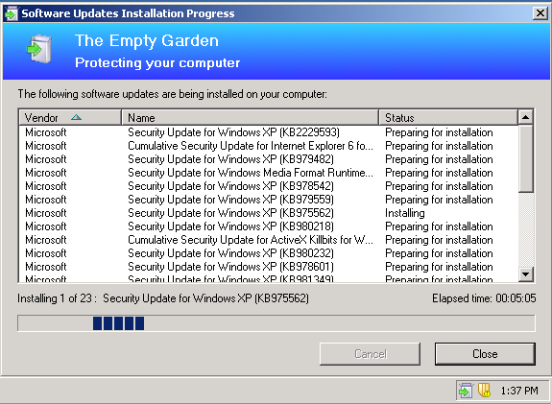

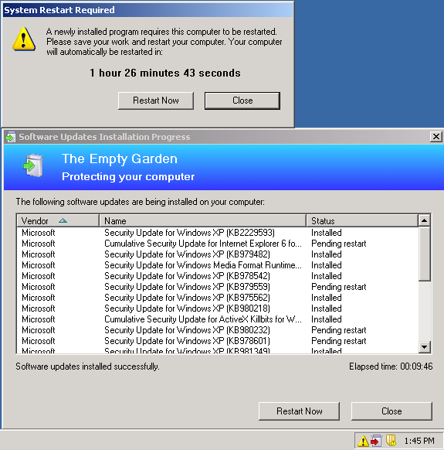

    - XP-2 and XP3
      - With the options that were selected, the end user has to install the updates and then gets prompted for a reboot.
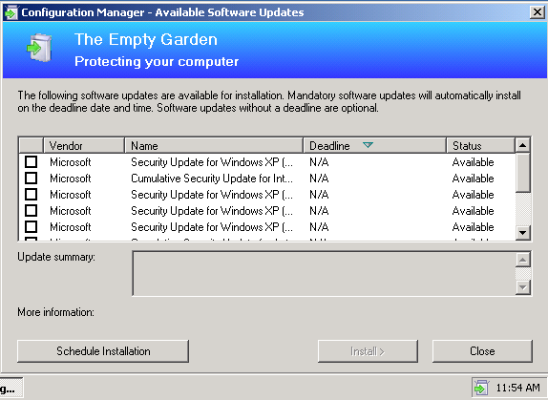
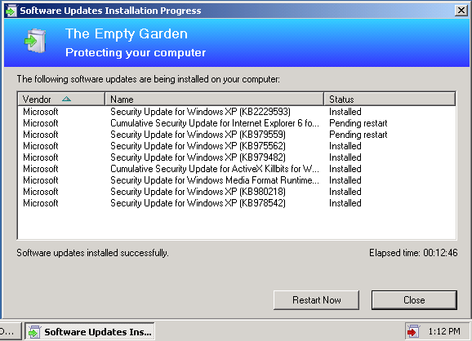
  - This option meets the needs of displaying messages; however, the end user would have to initiate the installation of the updates on the manual reboot machines.

TEST 3
- Test automatic reboot push and manual reboot push with the following settings
  - Software Update Client Agent

  - Two SCCM Collections have been set up
    - Workstations – Manual Reboot
      - XP-2
      - XP-3
        - NOTE: Both these machines will use the BDP on XP-3 as their content source
    - Workstations – Automatic Reboot
      - XP-1
  - Two SCCM Software Updates Deployment Management Packages
    - Workstation – 2010 Updates – Windows XP – Automatic Reboot
      - This will be targeted to the GBIS EUC – Automatic Reboot collection

    - Workstation – 2010 Updates – Windows XP - Manual Reboot
      - This will be targeted to the GBIS EUC – Manual Reboot collection
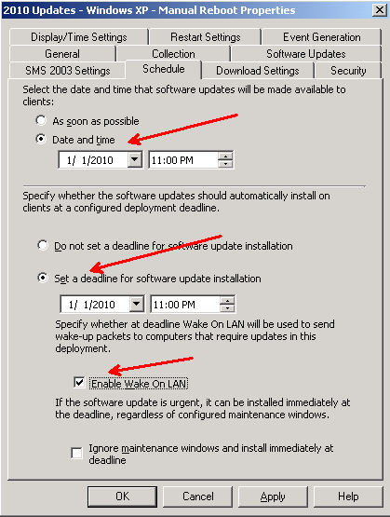

  - Results
    - Carlson XP1 – Part of the GBIS EUC Automatic Reboot collection
      - Looked at the ContentTransferManager.log to verify that the source files were being downloaded from the correct DP.
      - The Hide Deployment check box for the Software Updates Management Package seems to have no effect.

    - Carlson XP2 and Carlson-XP3
      - With the options that were selected, the end user does NOT have to install the updates. They will get prompted for a reboot.
  - This is the best option to meet the needs of installing updates automatically and prompting for reboots on business critical machines.

